FY 2007-2009 F&W Program Project Solicitation

Section 10. Narrative

This last section of your proposal is for text responses, explanations, and justifications that support the previous nine sections of the online form.

The Narrative is provided as a Word-compatible document (.doc suffix) that can be completed by inserting responses where indicated. The document will be submitted to CBFWA when completed.

To complete and return Section 10:
- View the instructions for this section at www.nwcouncil.org/fw/budget/2007/narrative.htm.
- Provide as much detail as you need in the spaces marked “(Replace this text with your response in paragraph form).” Do not leave parentheses around your response. Although there is no limit on the number of pages for the narrative section of the proposal, most narrative sections can provide sufficient detail in 10 pages, complex proposals in no more than 25 pages.
- You can insert tables, graphics or maps into this document. For help in adding graphics, contact Amy Langston at 503-229-0191 or amy.langston@cbfwa.org.
- This document will be viewed on the Internet. If you refer to online documents, include web addresses and use Word’s hyperlink tool to make those addresses active links in the document. Contact Amy for help.
- Please use Word’s spell-check tool before submitting this document.
- Save this document using your Proposal number or Project ID number (see Section 1) as the file name, and add an “n” to the end, like “198906201n.doc”.
- Return this document by browsing to your online proposal, choosing Section 10, then following the “Upload” instructions.
Project ID: 200100300

Title: Installation and Evaluation of Established PIT-tag Technologies

New title for Adult PIT-tag Detector Installation Work
A. Abstract

Project 200100300 was started in 2001 in order to fund the installation and evaluation of the interrogation systems for adult salmonids. Originally, this was for installation and evaluation of orifice-based interrogation systems, but PIT-tag technologies have developed quickly over the past few years, which has enabled larger and larger antennas to be fabricated. As a result of the technologies evolving, this project has also evolved over time as we recognized the need to assess the impacts of integrating PIT-tag technologies for extended-range systems that were not anticipated in 2001. We also now recognize that there are other established PIT-tag technologies, which once integrated might have a significant impact on how well the installed interrogation systems detect tagged adult and juvenile salmonids. Therefore, we now evaluate the potential impact of adopting alternative technologies such as new tag model before the technology is adopted or installed. It is important to point out that the focus of this project is on integrating finished products and not on developing new ones.

Within this project, PSMFC is responsible for installing the systems and NMFS is responsible for evaluating the installed systems. They work together to evaluate the potential impact of adopting alternative technologies because the agencies have different responsibilities. By working together, it ensures that a technology is ready for operations before it is adopted or installed.

This project will provide the funds for PSMFC, Digital Angel, and NMFS to support the U.S. Army Corps of Engineers in designing four extended-range systems into John Day, The Dalles, and Lower Monumental Dams. It will also provide the funds for procuring PIT-tag interrogation system electronic components and labor for assembly and installation of those four systems. This project will also fund the evaluations of the newly installed systems and an evaluation of how well all of the interrogation systems for adult salmonids at the FCRPS dams detect different populations of salmonids. We also plan to evaluate PIT tags from several different manufacturers when BPA’s exclusive contract with Digital Angel expires in 2007.

B. Technical and/or scientific background

Installation

PIT tags have been used since 1985 for research and monitoring of anadromous fish resources in the Columbia River Basin (CRB). In 1987, federal and state biologists began marking production lots of hatchery Chinook and steelhead, augmenting (and ultimately replacing) the established freeze-brand marking program. In 1988, federal, state, and tribal biologists expanded their research programs to include the PIT tag marking of juvenile wild salmon and steelhead.

In the Columbia River Basin, juvenile salmonids are injected with PIT tags, released, and then passively interrogated as they pass through bypass/collection fish facilities located at hydroelectric dams on the Snake and Columbia Rivers. The salmon then remain in the ocean for 1-4 years before returning to their original breeding grounds. During their homeward migration they must ascend a number of fish ladders located throughout the Columbia River Basin.

In 2000, the Basin completed a process to upgrade the region’s PIT tag interrogation system to International Standards Organization’s 11784 and 11785 (ISO FDX-B) specifications. One of the benefits of changing to this technology, was the potential to increase the read range of the tag, and detect fish at fish ladders. This was not possible with the PIT-tag systems used prior to 2000.

Most of the dams at the FCRPS projects have fish ladders. The ladders are of a weir and pool design. The weir walls have one or two orifices typically located near the bottom of the weir and close to the ladder walls. In addition, each weir has a complete or partial overflow. In 2001/02, orifice-based PIT-tag detection systems were installed at all fish ladders at Bonneville and McNary Dams.

By 2003, technology had improved sufficiently to install larger PIT-tag antennas into fish counting windows or vertical slots. These are superior to the orifice-based systems because every fish must pass through these antennas in order to transit the ladder. This lead to more detection systems being installed at Ice Harbor and Lower Granite Dams in 2004 and to improvements being installed at the Bonneville and McNary Dams in 2005 and 2006.

The fisheries community needs to install additional systems capable of detecting migrating juvenile and adult salmonids to aid in evaluating restoration strategies. That need is reflected in NMFS Biological Opinions that require data generated from the adult interrogation system to support investigations that address: 1) Smolt-to-adult return rates (SAR) information (to answer such questions as whether there is any survival differences between transported juveniles and those that migrated in-river); 2) conversion rates between dams (to track losses of fish between dams, straying rates and routes; 3) estimations of travel time between dams; and 4) fall-back rates for different fish ladders.

Furthermore, the addition of the full-flow systems at Ice Harbor (2006) and ones planned for Lower Monumental and John Day Dams will improve reach estimates for the different ESA-listed populations during their juvenile outmigrations. These potential extra data collection points are critical now that the fish managers are bypassing more fish via the dam spillways to improve survival of salmonids migrating through the federally operated hydroelectric dams within the Columbia River Basin. Therefore, we need to detect all of the tagged fish when they do go through the bypass facilities. The full-flow systems give the fish managers the option of getting those detections, but still passing the juvenile salmonids in larger volumes of water.

Evaluation

One of the overarching biological objectives for the Fish and Wildlife Program (and for all other regional plans) is the recovery of ESA-listed anadromous and resident fish affected by development and operation of the hydrosystem. A goal of the Action Agencies is to run the federal hydrosystem so that survival of the ESA-listed stocks is improved. They have established biological performance standards that they are trying to meet by making operational and structural changes at the FCRPS projects. Consequently, the fisheries community needs to be able to confirm whether operational or structural changes made at FCRPS projects to improve fish passage survival of listed fish are really improvements. This is being done with a region-wide RM&E program. Most of these research/monitoring projects rely to a large extent, or almost exclusively, on information gathered from PIT-tagged fish. The main objective of Project 200100300 is to install more monitoring systems, which will improve the effectiveness of the region-wide RM&E program. Obviously, installation is an important step, but evaluating the performance of the installed systems is an equally important step.

Project 200100300 was started in 2001 in order to solve the “problem” of funding the installation and evaluation of the interrogation systems for adult salmonids. Originally, this was for installation and evaluation of orifice-based interrogation systems, but PIT-tag technologies have developed quickly over the past few years, which has enabled larger and larger antennas to be fabricated. Consequently, it soon became possible to install interrogation systems around vertical slots, counting-station pathways, and bypass pipes. As a result of the technology evolving, this project has also evolved over time as we recognized the need to assess the impacts of integrating PIT-tag technologies for extended-range systems that were not anticipated in 2001. For example, a full-flow interrogation system to detect PIT-tagged juvenile salmonids was installed and evaluated in 2005 at Ice Harbor Dam. We also now recognize that there are other established PIT-tag technologies, which once integrated might have a significant impact on how well the installed interrogation systems detect tagged adult and juvenile salmonids. These would include new tag models and the development of a new computer program for controlling separation-by-code functions being developed by PSMFC. We also recognize that the future will bring other established PIT-tag technologies that we will want to integrate into our network of extended-range interrogation systems; however, it is important to point out that the focus of this project is on integrating finished products and not on developing new ones. Therefore, within the scope of the project, we generally evaluate installed systems or technologies; however, in some cases (e.g., new tags), we will want to evaluate the potential impact of that integration before the technology is adopted or installed.

Within this project, PSMFC is responsible for installing the systems and NMFS is responsible for evaluating the installed systems. They work together to evaluate the potential impact of adopting alternative technologies because the agencies have different responsibilities. PSMFC's responsibility is related to operations and maintenance and NOAA's responsibility is to ensure that a technology is appropriate for fisheries applications and that the technologies perform as advertised. By working together, it ensures that a technology is ready for operations before it is adopted or installed.

After interrogation systems are installed, biologists and fisheries managers need to know the probability of detecting a PIT-tagged fish in a particular FCRPS fish ladder or dam in order to plan and evaluate study plans and make management decisions. Therefore, NMFS determines tag-reading efficiencies using inriver tagged salmonids from the major salmonid populations for the installed interrogation systems. The results are also used by the fish managers to decide whether additional PIT-tag interrogation systems need to be installed or if the currently installed systems need to be modified (additional interrogation units added or antennas replaced).

At dams where juvenile salmonids are not collected for transport, the fish managers have decided to install extended-range interrogation systems around larger structures (e.g., transport pipes) so that the fish can be returned to the river without having to go through small flumes or pipes, which can be stressful. The current schedule calls for systems to be installed at John Day and Lower Monument Dams in FY07.

Extended-range interrogation systems for adult salmonids are still needed for John Day and The Dalles Dams because there are fish losses in these reaches that cannot be accounted for. The current schedule calls for systems to be installed at John Day Dam in FY08 and at The Dalles Dam in FY09.

Because the exclusive tag contract between BPA and Digital Angel is set to expire in 2007, we are anticipating that other manufacturers will want BPA to buy their tags. However, before a tag can be used within the Columbia River Basin, it needs to pass a series of performance tests to ensure that it can perform at a satisfactory level. The fish data that are collected from PIT-tagged salmonids are too critical to choose tags on price alone.

C. Rationale and significance to regional programs

One of the overarching biological objectives for the Fish and Wildlife Program (and for all other regional plans) is the recovery of ESA-listed anadromous and resident fish affected by development and operation of the hydrosystem. The Action Agencies make operational or structural changes at FCRPS projects to improve fish passage survival of listed fish. They then support a region-wide RM&E program to determine if the changes are successful. Since the RM&E program relies on PIT-tag data for their analyses, the installation and evaluation of newly installed PIT-tag interrogation systems or adopted PIT-tag technologies helps to improve the accuracy of their analyses. For example, by expanding the collection of PIT-tag data, estimates of reach survival estimates for juvenile salmonids from ESA-listed populations are stronger statistically. Furthermore, more detections at different sites help make SAR estimates more accurate as well.
D. Relationships to other projects

PTAGIS maintains a continuous and cooperative relationship with the Columbia River Basin PIT Tag Steering Committee, the US Army Corps of Engineers (Portland and Walla Walla Districts), Bureau of Reclamation, US Fish and Wildlife Service, National Marine Fisheries Service, the States of Idaho, Oregon and Washington, Portland General Electric, Chelan PUD, Grant Co. PUD, the Direct Service Industries, University of Idaho, University of Washington, Oregon State University, other academic institutions, and other agencies.

The PIT Tag Information System project provides all historical information on PIT tagged fish in the Columbia Basin since 1986.

PTAGIS collects and distributes ‘raw’ PIT tag information. PTAGIS does not perform analysis of PIT tag information except to determine coil and monitor efficiencies for PIT tag systems operation. Analysis of PIT tag information is left to research agencies and others. The responsibility of PTAGIS is to provide the best, most objective PIT tag information to all users.

The Fish Passage Center Data System is specifically designed to facilitate and support the daily, weekly, monthly and annual analysis which is the foundation of juvenile and adult fish management decisions made by fisheries agencies and tribes. FPC utilizes PIT tag information as part of these analyses.

StreamNet provides data for Fish and Wildlife Program Monitoring and Planning. StreamNet may provide links to PIT tag data, but the StreamNet dataset does not include any PIT tag information.

FWP Projects, 199105100 and 198910700 are sponsored by the University of Washington (Monitoring and Evaluation Statistical Support and Statistical Support for Salmonid Survival, respectively). Both of these projects rely upon the “Technical Management Team” data set that is compiled by the PTAGIS system on a daily basis. The PTAGIS data set is the basis for the PIT component of the Columbia River DART web site sponsored by University of Washington.

The PTAGIS project has always maintained a symbiotic relationship with NMFS as sponsors of the FWP, New Marking and Monitoring Techniques for Fish (198331900). This relationship will continue as the NMFS project focuses on the development of a new generation of PIT tag reader technology that will provide even greater read range, and the construction of arrays of PIT tag antennas in close proximity. This new technology will have applications that have not yet been considered. The PTAGIS system needs to be poised to take the product of the NMFS research and development efforts to the FWP research community and support it with production systems, processes and software.

The data collected by this project has been used by numerous other projects. Here are some examples from research on adult salmonids.

- A behavioral study of adults passing Bonneville's Bradford Island and Washington-Shore Ladders (https://www.nwp.usace.army.mil/pm/e/reports/afep/bon/adult_studies/CountingWindowApr2004.pdf)

- A study of adult migration through the lower Columbia River (https://www.nwp.usace.army.mil/pm/e/reports/afep/bon/adult_studies/00-01ForebayReleaseFinalDraft.pdf)

- Studies of dam passage and fallback (https://www.nwp.usace.army.mil/pm/e/reports/afep/bon/adult_studies/00-01BONfallback9Oct03CTB.pdf and https://www.nwp.usace.army.mil/pm/e/reports/afep/system/Burke_et%20al%20-%20Pit_Radio_Report.pdf)

- Studies of adult straying in the lower Columbia and lower Snake Rivers (https://www.nwp.usace.army.mil/pm/e/reports/afep/system/Strayingletterreport29Nov04.pdf and ttps://www.nwp.usace.army.mil/pm/e/reports/afep/system/Straying_UI_NMFS_Final.pdf)

- A study of passage/migration times through the hydrosystem (https://www.nwp.usace.army.mil/pm/e/reports/afep/system/Passage_Times_UI_Apr_05.pdf)

- A study of escapement, harvest and unaccounted loss through the Hydrosystem (https://www.nwp.usace.army.mil/pm/e/reports/afep/system/COE_Escapement_31_Mar_05.pdf)

- The Comparative Survival Study (http://www.efw.bpa.gov/Publications/D00006203-5.pdf)

- The NOAA white paper on juvenile and adult passage (http://www.nwfsc.noaa.gov/assets/25/6048_04222005_105920_fishpassagetm64final.pdf)

- The NOAA white paper on effects of the FCRPS on salmonids (http://www.nwfsc.noaa.gov/assets/25/6061_04142005_152601_effectstechmemo63final.pdf)

E. Project history (for ongoing projects)

Installation

2002
- Installed orifice PIT tag detection systems into Cascade Island (site BO2) and Bradford Island (BO1) Fish Ladders at Bonneville Dam
- Installed orifice PIT tag detection systems into Oregon (MC1) and Washington (MC2) Fish Ladders at McNary Dam

2003
- Installed orifice and vertical-slot PIT tag detection system at Lower Granite Dam (GRA)
- Installed orifice and vertical-slot PIT tag detection system at Ice Harbor Dam (IHA)

2004
- Nothing was installed.

2005
- Installed vertical-slot PIT tag detection system into Washington Shore Fish ladder at Bonneville Dam (BO4)
- Installed full-flow PIT tag detection system at Ice Harbor Dam (IHA becomes ICH)

2006
- Installed vertical-slot PIT tag detection system into Bradford Island Fish ladder at Bonneville Dam

BO1

BO2
MC1
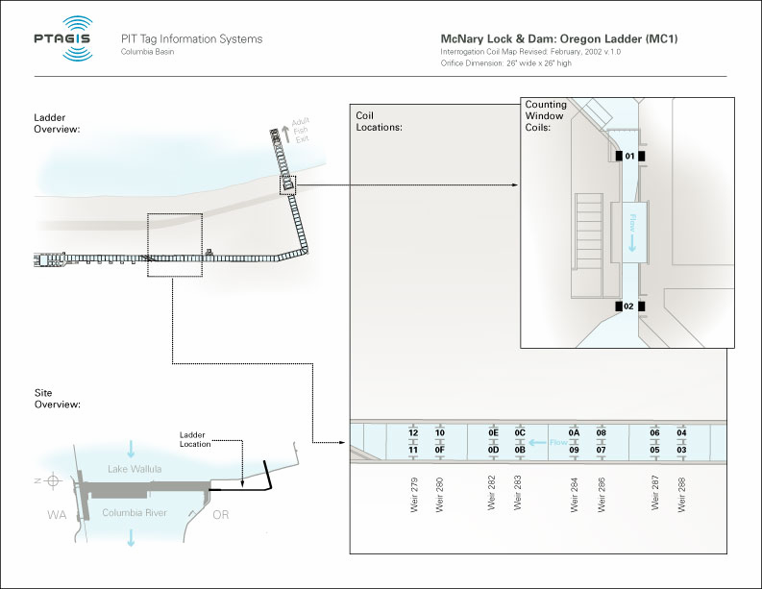

MC2
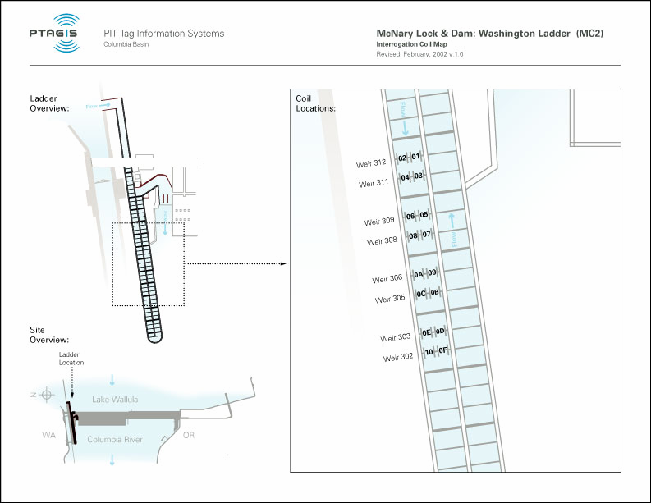

BO4
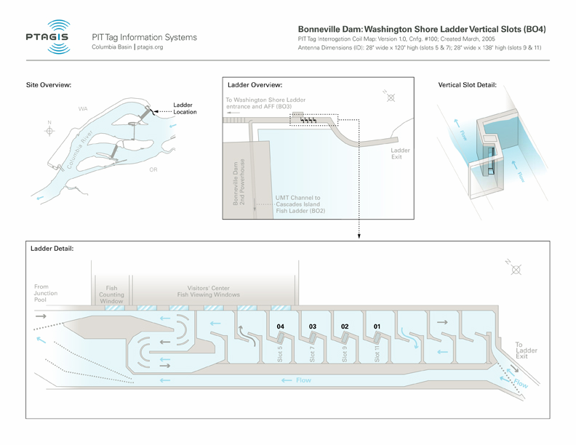

ICH
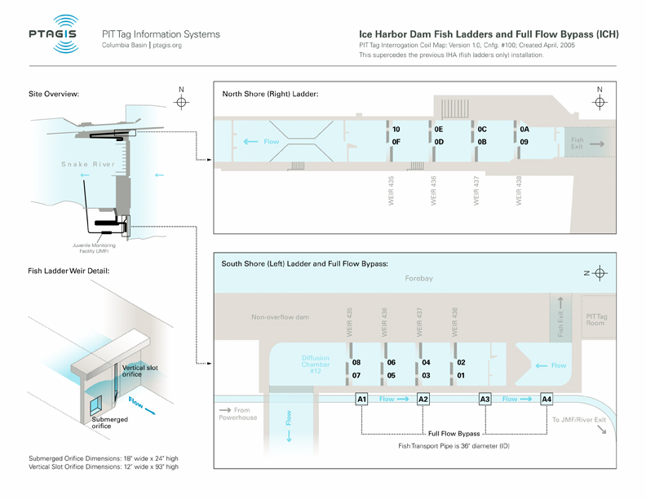

Evaluation

2002
- Evaluated the performance of the installed systems by using inriver detections to estimate of reading efficiencies for different salmonid populations ascending the ladders at Bonneville and McNary Dams
- Evaluated the performance of the installed system at Washington Shore Ladder at Bonneville Dam using salmonids tagged in the Adult Fish Facility
- Compared the performance of the counting-window and orifice-based interrogation systems installed into Oregon Ladder at McNary Dam
- Evaluated the performances of individual interrogation units (antenna, antenna cable, and transceiver) to determine whether any of the orifice antennas need to be replaced

2003
- Evaluated the performances of the orifice and vertical-slot PIT tag detection systems at Lower Granite and Ice Harbor Dams using inriver salmonids
- Evaluated the performance of the installed systems by using inriver detections to estimate of reading efficiencies for different salmonid populations ascending the ladders at Bonneville, McNary, Ice Harbor, and Lower Granite Dams

2004
- Evaluated the performance of the installed systems by using inriver detections to estimate of reading efficiencies for different salmonid populations ascending the ladders at Bonneville, McNary, Ice Harbor, and Lower Granite Dams

2005
- Evaluated the performance of vertical-slot PIT tag detection system into Washington Shore Fish ladder at Bonneville Dam using salmonids tagged in the Adult Fish Facility
- Evaluated the performance of full-flow PIT tag detection system at Ice Harbor Dam
- Evaluated the performance of interim production PIT tag (model TX1400SGL)
- Evaluated the performance of the installed systems by using inriver detections to estimate of reading efficiencies for different salmonid populations ascending the ladders at Bonneville, McNary, Ice Harbor, and Lower Granite Dams
- Evaluated the impact of the half-duplex PIT-tag system on the full-duplex PIT-tag system

2006
- Evaluated new production PIT tag (model TX1400SST)

It would take too long to present detailed information on how over time these systems have demonstrated improved detection efficiencies or to include available efficiency test results from all of these evaluations, but we will provide a few examples. The evaluations in 2002 for the Oregon Ladder at McNary Dam demonstrated that during the fall of 2002, the orifice-based system detected slightly more tagged fish (99.4%) than the counting-window system (98.6%), but both systems performed excellently. In contrast, analyses for 2002-2004 demonstrated that the orifice-based systems were missing large numbers of Upper Columbia Summer Chinook Salmon at McNary Dam because they tended to use the weir overflows. This behavior was significant because most of these fish (like all of the other Upper Columbia salmonid populations) use the Washington Ladder, which did not have a counting-window system, to pass McNary Dam. Calculations showed that up to 30% of the tagged fish might be being missed. Consequently, to improve detection of all Upper Columbia salmonid populations, the fish managers agreed to install a counting-window system into the Washington Ladder for 2006.

The evaluations over the years have consistently shown that the orifice-based system Washington Shore Ladder at Bonneville Dam have not detected surface-oriented salmonids well (e.g., fall Chinook salmon, coho salmon, and the B-run steelhead had reading efficiencies of 72.7, 79.0, and 90.4%, respectively in 2001). In 2005, after the vertical-slot system was installed, groups of these fish were tagged again. The results showed improved detection for all populations at the orifice-based system (BO3) and how much better the vertical-slot system (BO4) detected the surface-oriented salmonids. It needs to be emphasized that it was not possible to install vertical-slot system with antennas as large as those used at Bonneville Dam until 2005. When the original orifice-based systems were installed in 2001, a 2’ by 2’ antenna was the largest size possible.

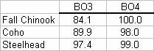

Another point that the 2005 evaluation at Washington Shore Ladder verified was that the newer tag models were being detected significantly better in these large antennas than the older FDX-B tags. For example, for one of the larger antennas, detection of fall Chinook salmon was 81% for the fish tagged with BE tags and 100% for fish tagged with ST tags. Similarly, tests conducted in May 2006 to assist in setting up the new PIT-tag detection system for the corner collector at Bonneville Dam (antenna measures 17’x 17’) showed that fish tagged with the latest tag model (SST) were detected at 69% compared to only 40% for the ST-tagged fish. Obviously, detecting higher percentages of fish will mean that estimates of reach survival and SARs for ESA-listed salmonids will be stronger statistically.

We hope that these examples demonstrate how this project is improving the detection of all PIT-tagged salmonids including those that are ESA-listed. These detections will aid the fish managers in determining whether the operational or structural changes made by the Action Agencies at FCRPS projects are helping to improve fish passage survival of listed fish. We have determine reading efficiencies for the main salmonid populations from the Upper Columbia and Snake Rivers for every year from 2001-2005. All of this information has been made available to the NOAA Regional Office and the Action Agencies to help them in deciding how well the currently installed systems have been performing over the years as well as deciding on where there are holes in the data and thus where future installations should be done (these would be provided if the reviewers would like to see them). For example, detection systems are needed at John Day and The Dalles Dams to help answer questions on poor survival in these reaches.

It is also worth mentioning that in the BiOp remand collaboration, we are talking about using PIT-tag detection data as the basis for the adult survival performance standards rather than in past BiOps where we used costly radio tag studies.

CONTRACT REPORTS

Downing, S. L. and E. F. Prentice. 2004.
Overview of the Performance of PIT-Tag Interrogation Systems for Adult Salmonids
at Bonneville and McNary Dams, 2002. Report to Bonneville Power Administration,
Project 200100300.

Downing, S.L, D. Chase, S. Livingston, B.F. Jonasson, M. Moser, E.F. Prentice, W. Daigle, and W. Leach. 2005.
Overview of the impact of the half-duplex system (HDX), installed into the fish ladders for evaluation of lamprey passage, on the full-duplex system (FDX) used to monitor salmonid passage.

Downing, S.L, D. Chase, S. and Bower, A. 2005. Evaluation of an applicant PIT tag for the Columbia River Basin (Vendor: Digital Angel Corporation and PIT tag model: TX1400SGL). Report to Bonneville Power Administration, Project 200100300.

Downing, S.L, D. Chase, S. and Bower, A. 2006. Preliminary evaluation of an applicant PIT tag for the Columbia River Basin (Vendor: Digital Angel Corporation and PIT tag model: TX1400SST). Report to Bonneville Power Administration, Project 200100300.

F. Proposal biological objectives, work elements, and methods

At dams where juvenile salmonids are not collected for transport, the fish managers have decided to install extended-range interrogation systems around larger structures (e.g., transport pipes) so that the fish can be returned to the river without having to go through small flumes or pipes, which can be stressful. The current schedule calls for systems to be installed at John Day and Lower Monument Dams in FY07.

Extended-range interrogation systems for adult salmonids are still needed for John Day and The Dalles Dams because there are fish losses in these reaches that cannot be accounted for. The current schedule calls for systems to be installed at John Day Dam in FY08 and at The Dalles Dam in FY09. The fish managers decided to install John Day Dam first because they are more concern about unaccounted losses and adult count discrepancies between John Day and McNary Dams. However, this order may change if the decision to completely rebuild a section of one of the John Day Dam to improve passage timing (information received in June 2006). Since that section includes the preferred location for the PIT-tag system, it would make sense to do both simultaneously. In these proposals, we outline our proposed schedules based on the best information known at the time, but we recognize that changes can occur and if they do, we would adjust our work elements accordingly.

Since the data collected for adult salmonids are so important for estimating reach survivals and SARs, NMFS evaluates the performance of all of the interrogation systems installed for adult salmonids each year. We do this by monitoring the detection of in-river fish from the main salmonid populations from the Upper Columbia and Snake Rivers. We use detection at upstream dams to determine which tagged fish should have gone through the systems installed in the downstream dams.

Below, we describe Work Elements that cover the installations and evaluations of extended-range systems that are scheduled to be installed over the next 3 years. However, because these projects are costly to install, their schedules do sometimes change because of funding decisions by the Action Agencies.

Because the exclusive tag contract between BPA and Digital Angel is set to expire in 2007, we are anticipating that other manufacturers will want BPA to buy their tags. Therefore, we anticipate that we will need to evaluate tags from other manufacturers to determine if they can meet the performance criteria established for PIT tags (Downing 2005). The fish data that are collected from PIT-tagged salmonids are too critical to choose tags on price alone. Thus, we have added a Work Element for evaluating tags.

Installation Work Elements - PSMFC

Work Element 1. Install Fish Monitoring Equipment

Work Element description This work entails final installation work required for the transceiver installation, antenna installation, antenna testing and function testing of entire system.

Methods
- Lab test the modified extended range transceivers
- Install the extended range transceivers
- Organize enclosures and install cable ends
- Test and troubleshoot entire system
- Pre-Water up antenna characterization and antenna QA performance tests
- Final System Tuning
- Document and label final installation

Deliverables

- Installation of antennas, transceivers, and other infrastructure required by the program (John Day, Lower Monumental, The Dalles)
Work Element 2. Provide Technical Review

Work Element description: Provide technical consulting for extended-range system installation.

Methods Attend meetings, site visits, conference calls etc.

Deliverables: Meeting Notes
Work Element 3. Submit Acquire Data

Work Element description Configure PIT Tag electronics room

Methods
Install the high speed interface panel, configure the data collection computer and function test data acquisition system.

Deliverables: Equipment is installed.

Evaluation Work Elements - NMFS

Objective: Evaluate the performances of newly installed or adapted PIT-tag technologies to help with the assessment of the effectiveness of management actions and strategies for recovery of ESA-listed fish populations.

Work Element 1 Analyze/Interpret Data

Work Element description Analyze the performances of interrogation systems for adult salmonids at FCRPS dams by determining tag-reading efficiencies for different salmonid populations ascending the fish ladders

Methods During FY07, we propose to continue analyzing the existing and the newly installed extended-range interrogation systems by determining PIT-tag reading efficiencies for the different salmonid populations (e.g., steelhead and chinook salmon, ocean type and stream type) and age classes ascending the fish ladders at Bonneville, McNary, Ice Harbor, and Lower Granite Dams. The analyses use detections of inriver fish. This will provide estimates of the performance during 2008. These analyses will be expanded to include John Day and The Dalles Dams when those systems are installed.

These evaluations are critical for researchers and managers that use the data collected at the different extended-range interrogation systems for their monitoring and evaluation of mitigation actions. The different levels of confidence in the data are necessary for making accurate SAR and other survival estimates. As has been true for every year that the systems have been evaluated, the 2008 evaluation will also indicate whether the current interrogation systems are satisfactory or if further development is necessary.

We will also calculate or record on a biweekly schedule, number-of-reads per fish, individual antenna currents, and relative weir counts to determine if performances of individual interrogation units (antenna, antenna cable, and transceiver) are degrading at all (especially the antennas that contain moisture). These records are then kept to yield a yearly index that can be compared to earlier annual indices. This work will be done in conjunction with PSMFC in helping to determine whether any antennas need to be replaced.

The data analyses of the individual populations have assisted PSMFC in its operation and maintenance of the interrogation systems for adult salmonids because they have found problems that their O&M systems do not catch. PSMFC mostly deals with analyzing short-term problems and not following long-term performance. Thus our independent analyses complement nicely with theirs to keep the install systems operating smoothly.

Deliverable Report summarizing the different analyses used to monitor the entire network of interrogation systems throughout the Columbia River Basin.

Work Element 2 Produce/Submit Scientific Findings Report

Work Element description Evaluation of extended-range system for juvenile salmonids installed at John Day Dam

Methods In FY07, a new interrogation system for juvenile salmonids using established technologies will be installed into John Day Dam. This may be a full-flow system that is installed around the transport pipe or one installed around the collection bypass chute; either one of these designs will be easily adapted using established PIT-tag technologies. NMFS proposes to determine tag-reading efficiencies using inriver tagged salmonids from the major salmonid populations. Since we expect that the system will have reading efficiencies ≥90%, then we will tag 500-1000 fish from each population (spring Chinook salmon, steelhead, and fall Chinook salmon) to give results with precision levels of 2-3%. We are anticipating that we will need to rent a crane to assist with the fish evaluation.

Deliverable Report summarizing the tag-reading efficiency results from the fish test

Work Element 3 Produce/Submit Scientific Findings Report

Work Element description Evaluation of extended-range system for juvenile salmonids installed at Lower Monumental Dam

Methods In FY07, the fisheries community is planning on installing a PIT tag interrogation system onto main transportation flume at Lower Monumental Dam. The transportation flume is a U-shaped flume of corrugated metal that is 2-3 feet wide. Therefore, this installation will be similar to the full-flow systems installed around the transport pipes at McNary and Ice Harbor Dams.

NMFS proposes to determine tag-reading efficiencies using inriver tagged salmonids from the major salmonid populations. Since we expect that the system will have reading efficiencies ≥90%, then we will tag 500-1000 fish from each population (spring Chinook salmon, steelhead, and fall Chinook salmon) to give results with precision levels of 2-3%. We are anticipating that we will need to rent a crane to assist with the fish evaluation.

Deliverable Report summarizing the tag-reading efficiency results from the fish test

Work Element 4 Develop RM&E Methods and Designs

Work Element description Support for designing a PIT-tag interrogation system for adult salmonids at John Day Dam

Methods The fish managers have decided to move forward with designing a PIT-tag interrogation system for adult salmonids at John Day Dam. This extended-range system is scheduled to be installed during FY08. In order to design this system, PSMFC, Digital Angel, NMFS and the Corps need to conduct site visits in FY07 to determine possible locations for the system and to discuss potential designs. We then will hold meetings to determine the best location and design. After it is installed, NMFS proposes to evaluate the performance of the installed system using inriver salmonids in FY08.

Deliverable No deliverable will be necessary in FY07. In FY08, we will write a report that would include a description of the system and a summary of the performance evaluation.

Work Element 5 Develop RM&E Methods and Designs

Work Element description Support for designing a PIT-tag interrogation system for adult salmonids at The Dalles Dam

Methods The fish managers have also decided to move forward with designing a PIT-tag interrogation system for adult salmonids at The Dalles Dam. Although this extended-range system is not scheduled to be installed until FY09, since we will be conducting site visits to neighboring John Day Dam, it makes sense to visit The Dalles Dam on the same trips. As stated above, these site visits are to determine possible locations for the system and to discuss potential designs. Meetings would then be held to discuss the best location and design. After it is installed, NMFS proposes to evaluate the performance of the installed system using inriver salmonids in FY09.

Deliverable No deliverable will be necessary in FY07. In FY09, we would write a report that would include a description of the system and a summary of the performance evaluation.

Work Element 6 Produce/Submit Scientific Findings Report

Work Element description Evaluation of PIT tags from several manufacturers

Methods The contract between BPA and Digital Angel that guarantees a low price per tag in exchange for exclusively buying tags from Digital Angel is set to expire in 2007. We anticipate that other tag manufacturers will want to have a chance to sell their products to BPA. However, before a tag can be used within the Columbia River Basin, it must pass a series of performance test designed to determine that it could operate successfully in the network of installed PIT–tag interrogation systems (Downing 2005). We would also recommend that before any tag model gets approved for use by most, if not all, BPA projects that a fish test be conducted. Therefore, we are including the costs for running a fish test in the FY08 budget.

Work Element 7 Manage and Administer Projects

Work Elements description Project administration costs for NMFS

Methods Proper project administration is necessary to ensure that this project stays on track with its work schedules. Project administration involves planning and then monitoring the work and budget to make certain that the milestones are reached and the project stays within budget. It also involves writing project plans and PISCES status reports. In FY09, this work element will include writing the next 3-year proposal for the Fish and Wildlife Program solicitation.

Deliverables Each year, NMFS will submit a SOW to BPA detailing the plans for that year. This is important step for this project because these are costly projects to install and so their schedules do sometimes change because of funding decisions by the Action Agencies. We will also submit PISCES status reports to BPA.

G. Facilities and equipment

The PTAGIS field office in Kennewick, WA, houses electronic test benches and equipment to facilitate the testing and repair of interrogation system electronics. The equipment includes test "tunnels" connected to a programmable logic controller (PLC) and frequency drive that allows highly accurate testing of reading efficiency of interrogation electronics and tags in a laboratory environment. Other equipment includes oscilloscopes, function generators, multi-meters and other various electronic equipment. The field engineers are equipped with service vehicles for site visits which are scheduled weekly during the peak of the out migration season. These vehicles accumulate over 20K miles each per year and are on a three year depreciation schedule.

The computer platforms located at the PIT interrogation sites utilize a “Windows ‘98” network connected to primary and backup data collection computers (this mini-network is referred to at the Interrogation Data Collection Platform, IDPC). The IDPC server is connected through the Corps of Engineers internet connection to the PSMFC data center in Gladstone at three of the Walla Wall projects and at John Day. The other projects rely on PTAGIS supported telecommunications interfaces (IP, Dial-up or Satellite) to transmit data between the field location and the PSMFC data center. The above data systems and electronic test equipment are suitable based upon contemporary standards.
H. References

Reference (include web address if available online)
http://www.ptagis.org
I. Key personnel

For NMFS

Sandra L. Downing – see attached resume.

